**Task 4: Grid-Connected PV Plant Performance**

**Objective**: Analyse the monthly energy output of the designed PV system and evaluate the impact of temperature.

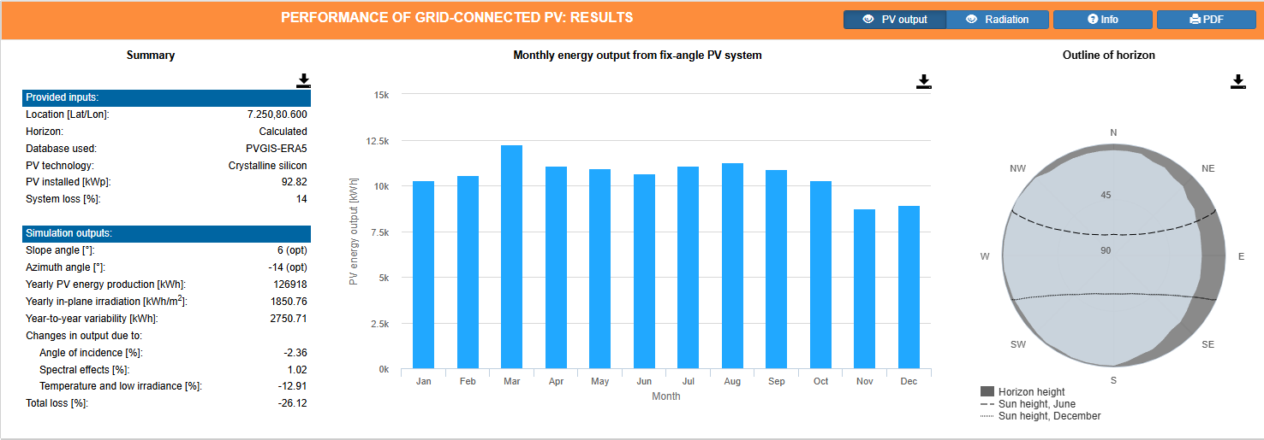

FIGURE XX: Monthly Energy Output

a) Monthly Energy Output:

* Installed Peak PV Power = 92.820kWp
* Yearly PV Energy Production =126918kWh
* Estimated System Losses = 14%
* Slope of mounted PV grid(opt) = 6 $°$
* Azimuth of PV grid = -14 $°$

TABLE XX: Monthly Energy Output data

|  |  |
| --- | --- |
| **Month** | **Energy Output (kWh)** |
| January | 10257.11 |
| February | 10580.58 |
| March | 12231.63 |
| April | 11064.87 |
| May | 10950.88 |
| June | 10674.35 |
| July | 11058.40 |
| August | 11277.14 |
| September | 10910.28 |
| October | 10273.00 |
| November | 8732.66 |
| December | 8907.11 |

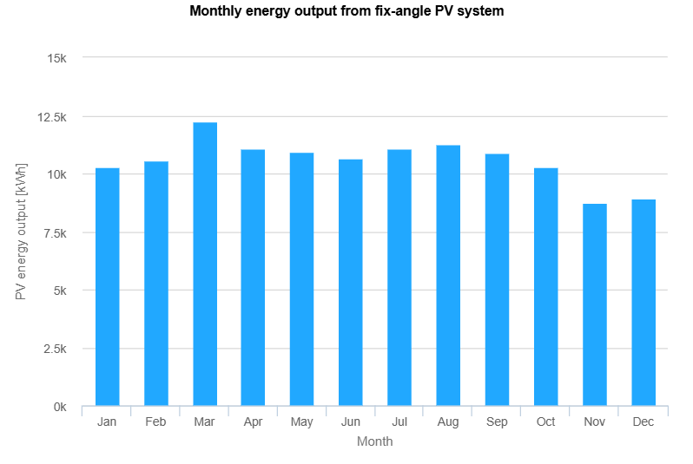

FIGURE XX: Monthly Energy Output

b)Temperature Impact:

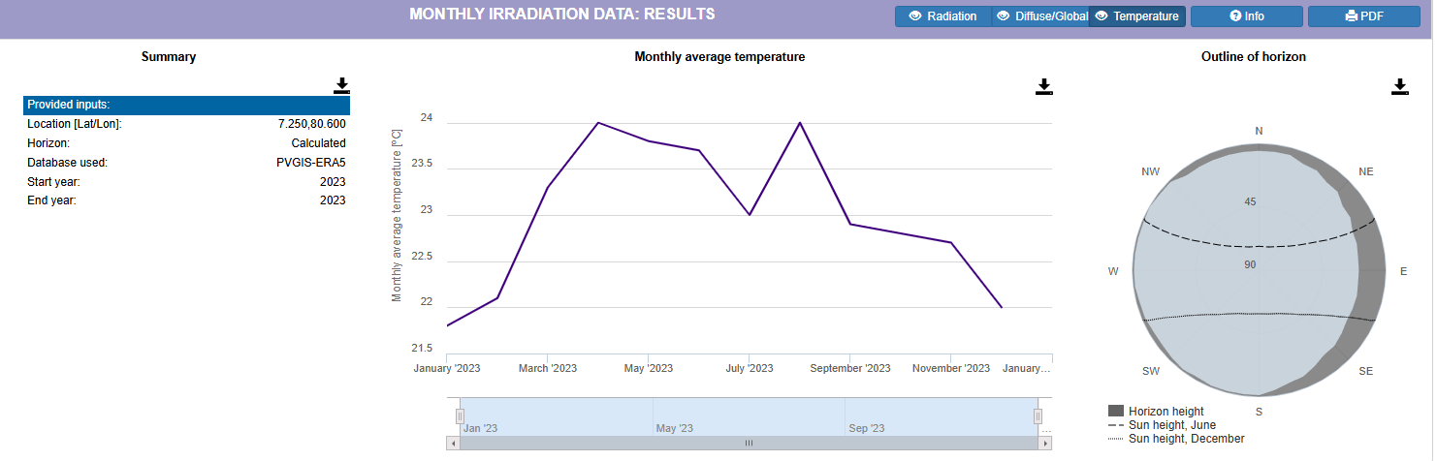FIGURE XX

TABLE XX: Monthly Average Ambient Temperature

|  |  |
| --- | --- |
| **Month** | **Average Ambient Temperature ($℃$)** |
| January | 21.8 |
| February | 22.1 |
| March | 23.3 |
| April | 24.0 |
| May | 23.8 |
| June | 23.7 |
| July | 23.0 |
| August | 24.0 |
| September | 22.9 |
| October | 22.8 |
| November | 22.7 |
| December | 22.0 |

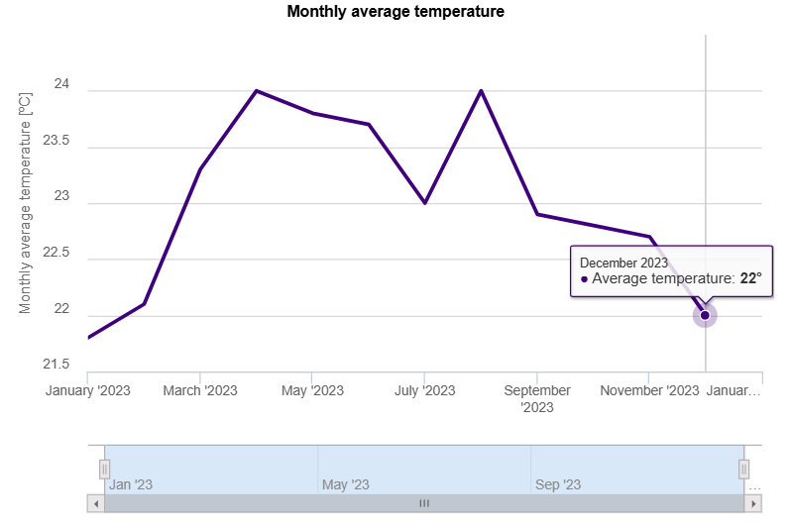

FIGURE XX: Monthly Average Temperature Variation

**(b) Temperature Impact, Comparison with Energy Output and effect of cell temperature on PV panel efficiency and power output**

**TABLE XX: Monthly Energy Output vs Temperature Comparison**

|  |  |  |  |
| --- | --- | --- | --- |
| **Month** | **Energy Output (kWh)** | **Average Ambient Temperature (°C)** | **Temperature Deviation from 25°C** |
| **January** | **10,257.11** | **21.8** | **-3.2** |
| **February** | **10,580.58** | **22.1** | **-2.9** |
| **March** | **12,231.63** | **23.3** | **-1.7** |
| **April** | **11,064.87** | **24.0** | **-1.0** |
| **May** | **10,950.88** | **23.8** | **-1.2** |
| **June** | **10,674.35** | **23.7** | **-1.3** |
| **July** | **11,058.40** | **23.0** | **-2.0** |
| **August** | **11,277.14** | **24.0** | **-1.0** |
| **September** | **10,910.28** | **22.9** | **-2.1** |
| **October** | **10,273.00** | **22.8** | **-2.2** |
| **November** | **8,732.66** | **22.7** | **-2.3** |
| **December** | **8,907.11** | **22.0** | **-3.0** |

Key Observations:

1. **Temperature Range**: The ambient temperature varies from 21.8°C to 24.0°C throughout the year, showing relatively stable tropical conditions.
2. **Energy Output Correlation**:
   * Highest energy output: March (12,231.63 kWh) with moderate temperature (23.3°C)
   * Lowest energy output: November (8,732.66 kWh) with cooler temperature (22.7°C)
3. **Seasonal Pattern**: The energy output doesn't directly correlate with temperature alone, indicating that solar irradiance plays a more significant role than temperature variations in this tropical location.

**Effect of Cell Temperature on PV Panel Efficiency**

Temperature Coefficient Analysis:

* Standard PV panels typically have a temperature coefficient of -0.4%/°C above 25°C
* Cell temperature is typically 20-30°C higher than ambient temperature under operating conditions
* Estimated cell temperatures: 42-54°C during peak sun hours

Efficiency Impact Calculation: For ambient temperature of 24°C (highest):

* Estimated cell temperature: ~50°C
* Temperature rise above STC (25°C): 25°C
* Efficiency loss: 25°C × 0.4%/°C = 10% power reduction

For ambient temperature of 21.8°C (lowest):

* Estimated cell temperature: ~47°C
* Temperature rise above STC: 22°C
* Efficiency loss: 22°C × 0.4%/°C = 8.8% power reduction

**C) Analysis:**

**• Explain how temperature variations influence the system’s performance and suggest design considerations (e.g., ventilation, panel type) to mitigate efficiency losses.**

**How Temperature Variations Influence System Performance:**

1. **Power Output Reduction**:
   * Higher cell temperatures reduce the band gap in silicon, decreasing voltage output
   * Current slightly increases, but voltage decrease dominates, resulting in net power loss
   * Maximum power point shifts to lower voltage values
2. **Performance Impact in Your System**:
   * Temperature variations of 2.2°C (21.8°C to 24.0°C) translate to approximately 1.2% difference in efficiency
   * While this seems small, it represents ~150 kWh annual energy difference for your 92.82 kWp system
3. **Long-term Effects**:
   * Thermal cycling causes material stress and potential degradation
   * Consistent high temperatures accelerate aging processes

**Design Considerations to Mitigate Efficiency Losses:**

1. **Ventilation and Mounting Systems**

* **Elevated mounting**: Ensure 15-20cm air gap beneath panels for natural convection
* **Open-back mounting**: Avoid enclosed systems that trap heat
* **Tilt optimization**: Your 6° tilt is good for this latitude but consider increasing to 8-10° for better air circulation

1. **Panel Selection and Technology**

* **Low temperature coefficient panels**:
  + Monocrystalline silicon: -0.35 to -0.40%/°C
  + Heterojunction (HJT) panels: -0.25 to -0.30%/°C (premium option)
  + Bifacial panels: Can provide additional energy to offset temperature losses
* **Consider PERC or half-cell technology**: Better heat dissipation due to improved cell design

1. **System Design Optimization**

* **String inverter sizing**: Account for temperature-induced voltage variations
* **DC/AC ratio**: Size appropriately considering temperature derating
* **Cable management**: Use temperature-rated cables and avoid heat accumulation

1. **Environmental Considerations**

* **Reflective surfaces**: Light-colored mounting structures to reduce heat absorption
* **Vegetation management**: Maintain clear airflow paths around the installation
* **Cleaning schedule**: Regular cleaning improves efficiency and reduces heat buildup from soiled surfaces

1. **Monitoring and Maintenance**

* **Temperature monitoring**: Install temperature sensors on representative panels
* **Performance ratio tracking**: Monitor system efficiency relative to expected output
* **Predictive maintenance**: Schedule cleaning and inspections during cooler months

**Economic Impact Assessment:**

For our 92.82 kWp system:

* Annual temperature-related losses: ~2,500-3,000 kWh
* Economic value (assuming Rs. 20/kWh): Rs. 50,000-60,000 annually
* Investment in better mounting and panel selection could provide 5-7 year payback

**Recommendations:**

1. **Immediate**: Ensure proper ventilation in current mounting system
2. **Future upgrades**: Consider panels with lower temperature coefficients when replacing
3. **Monitoring**: Implement temperature monitoring for performance optimization
4. **Maintenance**: Schedule cleaning during early morning hours to minimize thermal shock